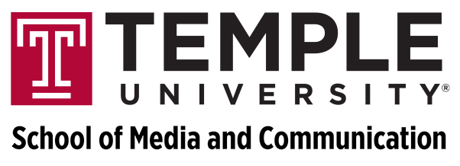

For Immediate Release

For Immediate Release Media Contact:
Feb. 25, 2014 Jeff Cronin, Asst. Director of Communications
215-896-0888
jcronin@temple.edu

TUTV to air live Q&A session with International Space Station crew

PHILADELPHIA — TUTV’s reach will extend more than 200 miles skyward on Thursday, Feb. 27.
Temple University’s television station will air “TUTV Presents: Space Station Live” from 11:55 a.m. to 12:15 p.m., featuring a live question and answer session between Temple University students and crew members of the International Space Station orbiting high above Earth.
Hosted by Karina Cheung, a junior media studies and production major and TUTV’s Rudman Intern, and Nick Lucier, a senior media studies and production major, the show will feature questions from students from the College of Engineering and the School of Media and Communication focusing on the science of space exploration. The engineering students are a part of Associate Professor John Helferty’s Student Space Exploration and Environmental Systems Laboratory, a program funded by NASA.
Paul Gluck, associate professor of media studies and production and general manager of TUTV, says the interview will be repackaged into a larger special to air on TUTV after Spring Break that will examine the history and future of space exploration.
“At TUTV, we think that, given the growing educational and professional emphasis on science, technology, engineering and mathematics, it’s is a part of our core mission to produce and present the kind of programming can help us better understand the world around us and the worlds we’ve yet to explore,” Gluck says.
The students will be speaking with American astronauts Mike Hopkins and Rick Mastracchio, as well as Koichi Wakata of Japan, from the space station’s Destiny lab module.
“As far as my engineering students are concerned, this is a chance of a lifetime to actually speak and ask questions to astronauts on the ISS,” Helferty says. “My students have been involved in NASA related activities and have worked with NASA personnel, but to actually talk to those few who are chosen to actually go to the ISS is an event they will never forget.”
Helferty says the allure of space exploration remains strong among college-aged students. A recent graduate, Craig Miller, ENG ’13, is now working on launch vehicles as a contractor at Kennedy Space Center.
“I am very happy to see how NASA’s space-related activities inspire our students to work on the many excellent projects that can be done right here at Temple,” Helferty says.
Programming like “Space Station Live” is made possible, in part, by a generous grant from the Kal and Lucille Rudman Foundation. TUTV can be seen within the city of Philadelphia on Comcast channel 50 and Verizon channel 45 or online at templetv.net.

###

